**Social Media Post**

**Blog, Facebook, Linked In, Twitter, Google+(KS), Sidebar Item in Training Email**

Change Needed to Kansas Facility SPCC Plans

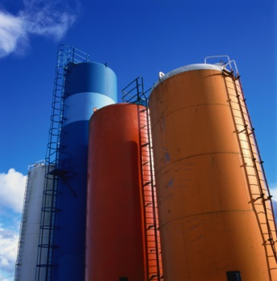KDHE has a new telephone number to use when you need to report a spill. This may affect your Spill Prevention Control and Countermeasure, or SPCC, Plans and therefore you’ll need to update them. The new number is 785-291-3333. Updated Spill Notification procedures can be found at [*http://www.kdheks.gov/spill/download/KS_Spill_Reporting.pdf*](http://www.kdheks.gov/spill/download/KS_Spill_Reporting.pdf)

Because this is considered an “administrative change” you can make the change yourself if this is the only change. Simply cross out the old phone number, write in the new number, and then initial it.

If you haven’t updated or reviewed your plan within the past 5 years, or if you’ve made changes to your facility since the plan was written, this would be a good time to update all of your plan. iSi can help you with this. Please contact us at [compliance@isienvironmental.com](mailto:compliance@isienvironmental.com) or give us a call at (888) 264-7050 for a price quote.

**Client Email to Past 3 Years SPCC Clients**

(I’ll send a personal email to all the people we’ve wrote SPCC plans to in the past 3 years. Emails will be sent to those who we did the SPCC as a separate project. COOP clients will NOT be included because COOP managers were instructed to notify their COOPs earlier – unless there’s any you want me to contact. I’ve found personal emails much more effective than mass mailer ones, especially for small groups.)

[Name]:

iSi has helped [Company name] with SPCC Plans in the past, so we’d like to give you a heads up on a new happening with Kansas Spill Notifications.

KDHE has a new telephone number to use when you need to report a spill. This will affect your SPCC Plan and therefore it’ll need to be updated with this new phone number. The new number is 785-291-3333.

Because this is considered an “administrative change” you can make the change yourself if this is the only change. Simply cross out the old number, write in the new number, and initial it.

However, if you have made any changes to your facility since the plan was written, this would be a good time to update all of your plan. If you need help fixing it, please email me back if and I can have our team send you a price quote for us to help you with this.

KDHE’s updated spill notification procedures with this new phone number in it can be found at h*ttp://www.kdheks.gov/spill/download/KS_Spill_Reporting.pdf*.

If you have any questions or have any other projects coming up that we may be able to help you with in the near future, please let me know. We very much appreciate the opportunity to work with you and [Company name]!

Tami Hadley

email signature block…